PRIESTLY PERUSINGS

As we enter the “High Holy Days” of our life as Christians, there is nothing more powerful for persons of faith than following in the footsteps of Our Savior Jesus Christ, tracing the final days of his life on this earth, his Passion and Crucifixion, and his glorious Resurrection from the dead. Attached to the end of this newsletter is a little booklet containing an explanation of the Holy Week liturgies and an invitation to participate fully and with abandon in the unique rites which trace the journey of Holy Week and Easter. Please try to put aside as much as you can of your ordinary day-to-day life and enter with us into these singular moments of contemplation and prayer. Your faith will be enlivened, your soul will be filled, your heart will be glad you did, and you will find yourself engaged by the Holy in a new and extremely personal way. May you know in this journey the Peace and the Presence of Christ.
.
Faithfully,
Susan+

THE BIBLE CHALLENGE CONTINUES The Bible Challenge, an international study, offers a new opportunity to read the whole Bible in one year and have some time for occasional “check-in” with one another to discuss and compare understandings and interpretations. Best of all, you can do it on your own schedule, on your own time, at home in the evening by the fireside, or over your morning coffee. Systematic readings from the Old

Testament, from the Psalms, and from the New Testament are assigned for each day of the year-long engagement. This program was developed by The Rev. Marek Zabriskie, Rector of St. Thomas’ Episcopal Church, Whitemarsh, PA, and an alumnus of Yale Divinity School. We began on January 20, but you can jump in and catch up at any time. Participants will need a Bible and the accompanying guide book, in which each day you will be accompanied by a meditation written by a church leader or biblical scholar. Over one hundred archbishops, bishops, deans, priests and scholars have contributed essays. The cost of the book is $14.00. (Of course, scholarship aid is always available). The book is available in print, or for Kindle or Nook tablets. If you are interested in joining this spiritual pilgrimage, please contact Mother Davidson.

A NEW OPPORTUNITY OFFERED BY THE ECUMENICAL CHURCHES IN You WOLCOTT: An ecumenical group in Wolcott is meeting on a regular basis to develop a monthly, Saturday afternoon worship and formation opportunity, based on an Episcopal resource curriculum, for children with autism, as well as those with other needs. The first “Second Sabbath” gathering is April 13, 3:30 – 4:15, at the Wolcott Congregational Church. Several of our own members are involved in the planning process. If you are interested, or know others who are, please speak to Mother Davidson or call the Rev. Sue Strachan at 203-879-4002.

GOLDEN WEDDING ANNIVERSARY CELEBRATION: The Diocesan Committee for Aging and Life Planning is preparing for a Golden Wedding Anniversary Celebration for couples married fifty years or more. This event will be held at Christ Church Cathedral, Hartford, on Sunday, May 5, 2013 at 5:00 PM. All three Bishops, Ian T. Douglas, James E. Curry and Laura J. Ahrens will be there to celebrate with you at this service. It will include the renewal of marriage vows and presentation of commemorative certificates to all couples. A reception will follow. If you were married on or before December 31, 1963, you are invited to participate in this joyful celebration. Please contact Mother Davidson and let her know if you and your spouse will attend. We can certainly provide transportation for any who would not be comfortable driving the distance to Hartford.
CALLING ALL CHURCHES IN THE WATERBURY DEANERY All parishioners are invited to attend an evening of Dialog on “The Changing Church,” with Bishop Laura Ahrens and Canon Audrey Scanlan will be held from 7 – 9 PM on Wednesday, April 10, at St. John’s, Waterbury. Refreshments will be offered. You may register at this Eventbrite link: http://changingchurchwaterbury041013.eventbrite.com#. We hope to see many parishioners there!

SUMMER CAMP INFORMATION HAS ARRIVED! Please see the bulletin board for more information and registration forms for camp sessions for children, teens, and specialty camps at Camp Washington (www.campwashington.org), Lakeside, CT and Incarnation Camp programs for children ages 7 - 15 (www.incarnationcamp.org), Ivoryton, CT. Both are ministries of the Episcopal Diocese of CT.

H ∙ O ∙ L ∙ Y ∙ W ∙ E ∙ E ∙ K

Dear Friends in Christ,

As we draw near to the conclusion of Lent and beginning of Holy Week, I want to invite you to participate fully and with spiritual abandon in the worship of Almighty God during this time in which we walk with Jesus through his final days on this earth and our souls are able to experience the divine Drama of human redemption as it unfolded in the life, death, and resurrection of Jesus Christ. It is this time that is at the very center of our lives as Christians, the very reason for our worship of God in Jesus Christ over the past two thousand years.

Sometimes it seems that we do some “strange” things in our worship at this time of year, and the services are often confusing for many, since they are quite different from the usual Sunday liturgies. So I would like to offer some background information about the solemn liturgies of Holy Week, so that you may be a bit more informed about the important days ahead, and so that your Easter celebration and your joy may be intensified. I think we

are all able to be more comfortable and accepting of liturgical actions if we at least know why we are doing such things.
I want Holy Week to be the very special experience for you that it has been for me for many, many years. Holy Week and Easter are part of the same drama. If we are fully to know and experience the joy of the Risen Jesus on Easter then we need to go with him to the Upper Room, the Garden of Gethsemane, to Calvary, and then into Hell. Finally, we are with him in the garden of the Resurrection.
It is spiritually and theologically impossible to separate the events of the Passion from those of Easter. Yet, even though the services of Holy week are different, ofttimes strange, sometimes embarrassing, and even a bit too long for many of us, they stand there to place us with Jesus that his life might become ours and our lives his. Our worship invites us to give ourselves to sounds, actions, and rites that we normally would not do. It invites us to go beyond our comfortable, middle - class,

Episcopal piety and enter into something much greater than our pride. We are invited to be a part of a DIVINE DOING, that is, God at work in the Church. At the Lord’s Table we are fed and nourished in a Eucharistic foretaste of the Heavenly Banquet, and we celebrate that glorious feast in this seamless garment of liturgy, wrapped about the Paschal mystery of our redemption.
Finally, please let us know of members of the parish family who may be ill or home-bound so that we may bring them their Easter Communion. This is not a burden – it is a great joy to share the Paschal Mystery in the Sacrament. May the Risen Christ live in you, that in his joy your life may be complete.

Faithfully,


PASSION/PALM SUNDAY

The Palm Sunday Liturgy has two distinct parts, each with its own tone and feeling. The first part, the Liturgy of the Palms, is a rite of joy and triumph. We recall the Lord’s entry into Jerusalem, when the people greeted him with cries of “Hosanna” (which means “save us”) and waved branches and scattered them in his path. The palms are blessed and distributed to the people. The color of the day is the color for martyrs – red. The Liturgy of the Palms will begin in

Andrews Hall where we will all gather, the palms will be blessed, and the entire congregation will process, singing, into the church, in reenactment of Our Lord’s entry into Jerusalem.
Then the atmosphere changes. We pray that God, “whose Son went not up to joy but first he suffered pain,” may lead us to find that the way of the cross leads to life eternal. The mood has changed. The passion is narrated in dramatic fashion, and the congregation takes their part as the crowd surrounding Jesus at his trial. It is now Holy Week, when in the words of the proper preface for the day, we celebrate Christ who was lifted high upon the Cross, to draw the whole world to himself, for he is the source of eternal salvation.

MAUNDY THURSDAY
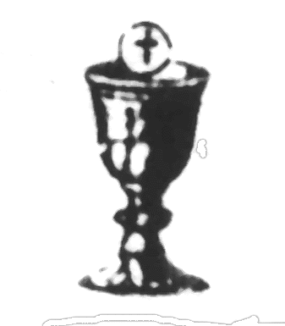
Maundy Thursday is the first of the three sacred (holy) days that constitute the Triduum Sacrum. This year, the Three Days begin at 7 PM on Thursday, March 28. I find it helpful to reflect upon four points as we prepare to worship on this day:
First, a theme of Maundy Thursday is unity. The liturgy is in the evening because it commemorates the evening meal shared by Jesus and his friends. Just as Our Lord and the Apostles gathered in the Upper Room to celebrate together, so do we as the
Christian family gather in one place at one time to celebrate our unity in Christ. There

is no greater expression of unity with one another and our unity with God than the Holy Eucharist. Thus, Maundy Thursday celebrates, recalls, and makes present again the Institution of the Eucharist by Our Lord Jesus Christ at the Last Supper.
Second, Jesus gave to his own a new commandment during the Last Supper. That new commandment, the mandatum novum (thus the name Maundy Thursday) is that we love one another as he loves us. How can we do this? Jesus gave us an example of what he meant. Jesus humbled himself and became a servant to wash the feet of the disciples. Some of them did not like this! Many of us are uncomfortable with this action even today. Yet, Jesus told Peter that we must be washed, and even wash each others’ feet as a sign of our love and humility toward each other and God. Those who wish may come forward to have their feet washed. (Tip for those who do: it’s a good idea to wear sandals or easily-removable socks.)
3
Third, it was the night of his Last Supper that Jesus was arrested in the garden of Gethsemane. At the conclusion of the Eucharistic worship the Altar and Sanctuary are stripped bare, and the sacramental Real Presence of Christ is removed to the Sacristy, where it is reserved for Communion on Good Friday. Fourth, the final stripping of the altar begins the Greater Silence of the Church. The liturgy ends abruptly – since, in fact, it is not an ending, but a pause, as we await the celebration of Good Friday.
We ask that you leave the church and the grounds in silence as you ponder in your heart this wondrous love offered for us.

GOOD FRIDAY

Friday in Holy Week is called “Good” Friday for on this day of Our Lord’s crucifixion and death salvation came into the world. Our worship reflects a paradoxical mood of penitence and sadness, mingled with exultation as we reflect on this wondrous Mystery. You are reminded that the Good Friday offering each year is sent to Jerusalem, to sustain the ministry of the Church in the Holy Land.
The GOOD FRIDAY LITURGY begins at 7 PM on March 29. It is the continuation of the Liturgy that began last evening and that will not end until the first Eucharist of Easter on Saturday night. At the beginning of this part of the service, the church is bare, and the ministers enter in silence. Silence begins the Liturgy of the word, which concludes with a dramatic reading of the Passion according to John. After a brief sermon, the liturgy continues with the prayers of the people in a slightly different form. The Solemn Collects of Good Friday are perhaps the most ancient form of the intercessions which we have available. There are five “blocks” of prayers: for the Church, for the world and those in authority, for the suffering, and for the mission of the Church. In each section, the Intercessor bids the prayers, a silence follows, and the Celebrant offers an appropriate Collect which sums up the intercessions.
4

The Veneration of the Cross follows. A wooden cross is carried into the church and elevated three times, with the acclamation “This is the wood of the Cross, on which hung the Savior of the world.” The cross is elevated at the same places where the Paschal Candle will be elevated at the Easter Vigil (at the Cathedral), reminding us that the Passion and the Resurrection of Christ are part of the same saving event. The priest and people now venerate the cross in ways which may be significant to them. In some places, it is customary for people to come forward, kneel at the foot of the cross, and kiss it or simply say a prayer before it (this is not a required devotion, but it is spiritually powerful to go to the cross and kneel before the crucified Lord); others may wish to simply remain kneeling in their place and gaze upon the cross in prayer.
Finally, Holy Communion is offered from the Sacrament consecrated and reserved on Maundy Thursday.
The Tabernacle is empty, the Sanctuary Lamp extinguished, and the church is left desolate. It feels sort of like the soul without Christ. This is a sad action, a draining experience. We don’t like to see God’s altar desolate, but such was the world and such is the soul without the living Christ.
Following the Good Friday Liturgy there is time to remain and offer our own silent prayers. This segment of the Triduum Liturgy again ends somewhat abruptly, because it is not really over. We pause for awhile before moving forward in this dramatic reenactment of the drama of our redemption.

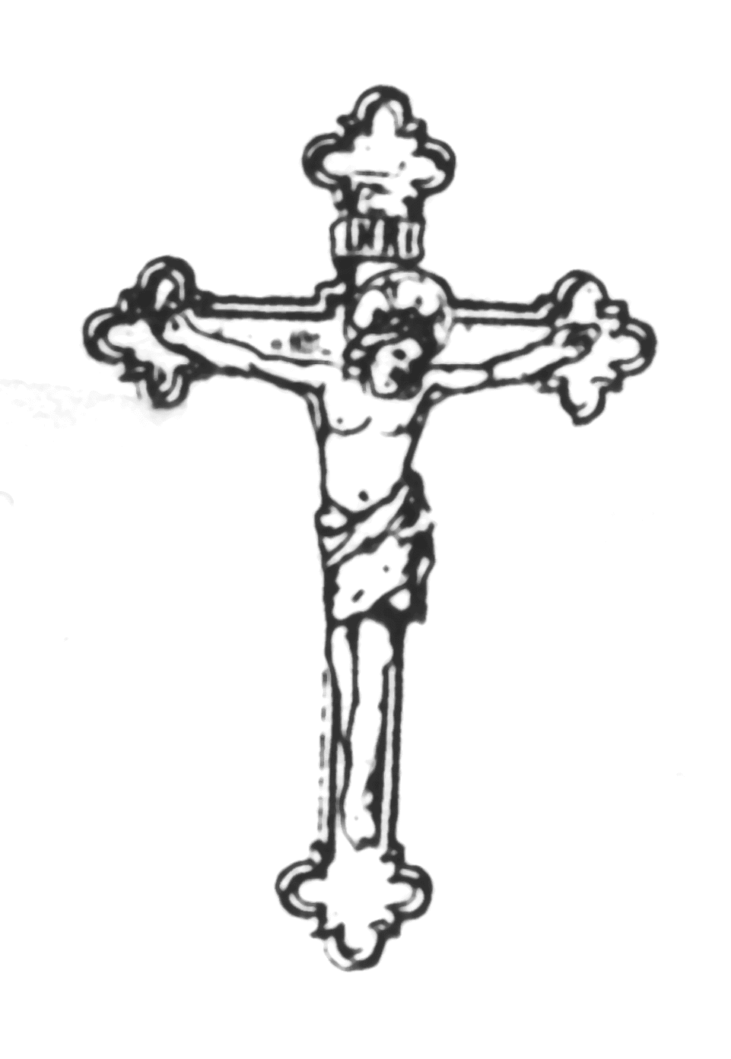
5
THE FEAST OF THE RESURRECTION



EASTER DAY

Easter Day (March 31 this year) is much like a usual Sunday, but with the restoration of alleluias and the Gloria in Excelsis, sung while ringing bells.
The Baptismal Font will be open in the central aisle, and filled with Holy Water during all of Eastertide, so that those who wish to may bless themselves with that water on their way in and out of church, as a reminder of the death and resurrection that we share in and with Jesus Christ in Baptism.

There will be no coffee hour on Easter Day, so that families may continue the festivities in their own ways.

If you are aware of parishioners who are homebound or hospitalized, please let us know, so that Easter Communion may be taken to them at home. This is not a burden, it is a joyful part of the ministry of the Church.

PLEASE REMEMBER TO BRING A BELL TO RING DURING THE GLORIA IN EXCELSIS!
May all fifty days of Easter be for you a glorious celebration of the Risen Lord!




HOLY WEEK AND EASTER SERVICES

AT ALL SAINTS’

March 24, Passion/Palm Sunday

begins 9:30 AM in Andrews Hall

March 28, Maundy Thursday

6:30 PM Soup Supper, Andrews Hall
Holy Eucharist, Foot Washing
and Stripping of the Altar

March 29, Good Friday
7:00 PM Good Friday Liturgy,
Including the Solemn
Collects, Veneration of the
Cross and Communion from
the Reserved Sacrament

March 31, Easter Day
9:30 AM Festival Holy Eucharist and
Resurrection of the Alleluias

